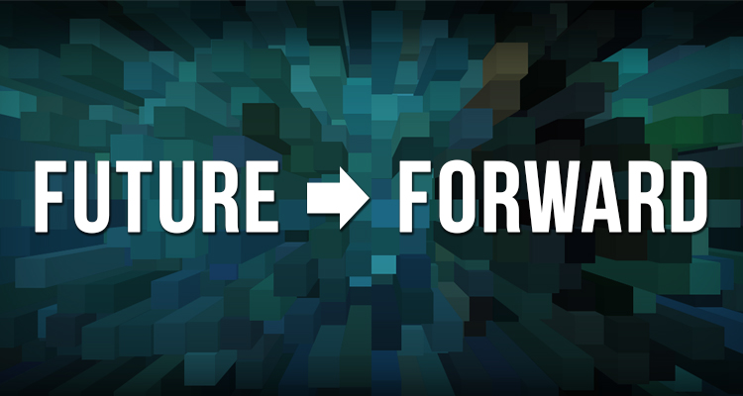
Group Discussion Guide

- What do you think of these four scenarios?

- Describe how likely or unlikely each scenario seems for Philadelphia’s future.
- Which trends are most important to address?

- How will these scenarios affect your organization or your career?
Consider these four aspects:

- The art or cultural programs you create – how might they be different?

- The audiences/participants you serve/attract – the same, or different than your current audiences/participants?

- The way your programs are delivered to audiences/participants – where people will experience your art?

- The funding /support for your programs and organization – how much will be available and where will it come from?

- What should we do now to prepare for these possible futures?
Such as:

- Increase our skills (technology, fundraising, entrepreneurship…)
- Change our approach to programming (in what way?)
- Change business models (in what way?)

Other ideas or comments?

