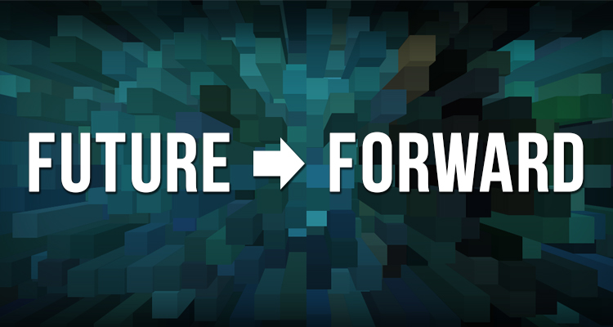
Scenario #1: America Bends Towards Justice

In 2035, the U.S. is feeling the positive effects of social justice movements, and the culture of America is more harmonious. The most successful arts and culture programs have high artistic quality while also being socially impactful and relevant to the community.
In the two decades since 2016, the U.S. population was transformed by a tremendous influx of new immigrants and refugees seeking to escape global unrest. They were attracted to America’s stability and economic prosperity. Immigration and high birth rates of people of color already in America created a new demographic landscape and a strong push for social justice. Today, our country is a true majority of minorities. The dominant groups are Hispanic and Asian, with 8 of the 10 largest cities having Hispanic or Asian mayors, including Philadelphia.
Politics has consequently shifted dramatically. After the divisive 2016 Presidential election, the Republican Party was unable to resolve the differences between its moderate and rightwing factions. It split in two, weakening its political influence. A new third party finally emerged, and succeeded: Under the banner of the Equity Party. This new coalition of Democrats and centrist Republicans marshalled the support of a diverse and politically active electorate and enacted an array of social reforms not seen since the 1930’s.
The new Equity Party spearheaded legislation on four platforms that have transformed the country:
- School Funding: First, a constitutional amendment was passed guaranteeing equitable public education for all. Funding for schools shifted from property taxes to a mix of progressive corporate and payroll taxes.

- Universal Healthcare: Second, a single-payer healthcare system was launched in 2029, leading to an economic boom as employers and the economy were relieved of the spiraling costs of healthcare.

- Criminal Justice Reform: Third, hundreds of former prisons were repurposed as technical training schools, community centers, or torn down to make parks and open space.

- Universal Basic Income: Fourth, and most dramatically, the Universal Basic Income system was instituted in 2030, making the first real dent in poverty since the New Deal. UBI has gradually eliminated the traditional safety net programs.

In 2023 Philadelphia hosted a landmark Constitutional Convention, leading to electoral reforms including compulsory online voting, term limits for all elected officials and comprehensive campaign finance reform. Voter turnout is now the highest in the world and political corruption is the exception not the rule.
Public schools are now fully funded and performing well, enabling more young families with children to live in the city. Arts and Culture is embedded in the core curriculum from K through 12th grade and buzzwords like “STEAM” are no longer needed to legitimize the value of arts education. The city has mandated that every school must have an art and music teacher, and every teacher must have creative professional development training, which cultural organizations provide for the district. A defined level of cultural proficiency is required in order to graduate high school.
Since 2020, the majority of philanthropic support has also shifted to focus on equity and social justice. As a result, social relevance, community impact and diversity have become the chief organizing principles of the arts and culture sector. Foundations, corporations, and individuals favor neighborhood-based arts and cultural programming.
While these changes have transformed the city and region in many positive ways, the new social order has also disrupted the traditional nonprofit cultural model. A cap on charitable deductions has shifted individual support from major philanthropists to broad, small scale donations by normal citizens. Many organizations have been unable to survive using their former business models. The most successful organizations have learned how to raise money by engaging new audiences and donors, by emphasizing activities that support tolerance, showcase diverse cultures, and create greater equity in society.
The most successful cultural nonprofits have coordinated their cultural programming with major social initiatives, and build strong relationships with many ethnic groups. Most cultural investment has shifted away from Center City to smaller scale community-based cultural centers embedded in culturally distinct neighborhoods. The broader base of grassroots philanthropy has enabled smaller nonprofits to attract new donors. However, it has hurt larger cultural organizations that depended on major gifts, because the traditional western canon no longer appeals to many residents. The emphasis on social impact, multiculturalism and education has put the cultural organizations that focus on this type of work front and center in terms of audience engagement, donor support, media coverage and civic awareness.
The emphasis on social value versus intrinsic value of the arts has also caused a shift in the cultural workforce. There are many more arts education jobs, and the typical arts leaders is a young dynamic person of color.

