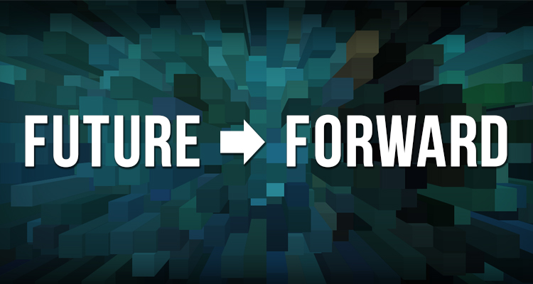
Character Script - Scenario #1: America Bends Towards Justice

Music has been a big part of my life since preschool. I can’t remember when I haven’t sung, or played different instruments so no matter where the music is from it’s easy to pick up the rhythms and jump right in.
I just returned from a trip to Brazil to study Samba music, part of the School District of Philadelphia’s Global Exchange program. Being there was amazing! And eye opening. Everywhere we went, you could see beautiful homes and nice restaurants, right next to people living on the streets. There were so many places that didn’t feel safe, we had to travel in groups. There is such a large gap between the very wealthy and the poor in that country.
Philly isn’t anything like that. We are all very different, but we also have a lot in common. I know people whose parents are very well off, and others who are recent immigrants and just getting a start, but Universal Basic Income gives everyone a starting place so we all live with dignity. And Philly schools give everyone a chance to succeed. School has lots of arts: drawing, dancing, making up plays, writing poetry...My teachers always tell me to be creative. It’s really helped me to understand how the world works.
Grandma says that growing up in Philly, African Americans, Latinos, Asians had less power and no voice. She also said that when she was a kid, the only arts experiences were at the big museums and concert halls, and you had to go downtown, unlike today where every neighborhood is full of arts and culture.
My home is South Philly, but I hang out and go to events all over the city. My friends are all over and from lots of different backgrounds - African American, Korean, Puerto Rican, Russian,… I love this city. Universal healthcare, free education through college, and the largest arts festival in the world! My friends from other countries look up to us because of what Philadelphia means: brotherly love, sisterly affection, democracy. I just don’t understand why some wealthy people still feel threatened and angry. Isn’t equal opportunity part of the American Dream?

