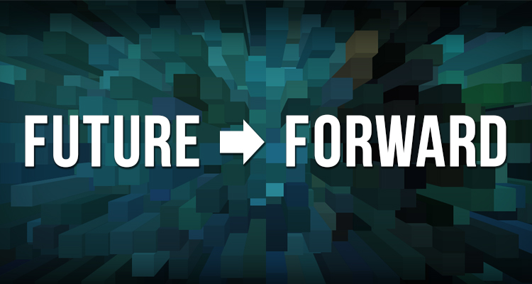
Character Script - Scenario #4: Philly Goes Global

I’ve lived in Philadelphia all my life. My family has been here for generations, and I wouldn’t want to be anywhere else. When I was growing up I never would have thought that we would be taken seriously on a world stage. Now, I’m head of an international corporation that’s located here, with clients in Shanghai, Tianjin, Mumbai, Delhi, Rio De Janeiro, and Santiago, providing legal consulting and business strategy to other international companies. It’s fascinating to navigate the business relationships between different legal systems and cultures, and it gives me great pride to see what kinds of contributions our region makes to the world.
And it really is the whole region. I live in Center City and take a lot of meetings there because it’s closer to the airport, but my offices are based out in Bucks. I’ve seen a lot of major industry players expanding out into what years ago would have been referred to as “the counties” or “the suburbs.”
Finding the right talent is the single most important factor for our success, and the arts and culture of Philadelphia is a major draw. Half of my employees are American, the other half from around the world. When we recruit, we always show off the arts and culture scene.
I’ve noticed, however, that a lot of the theater and dance companies and community arts centers I loved growing up have been pushed out. There used to be a lot more unique organizations, many of them kind of quirky and kind of charming. I was on the board of one for a while and when the major donor passed away, there wasn’t enough support anymore to continue. But from a larger perspective, maybe it’s a good thing that the arts and culture sector has aligned to the market, just as businesses do. After all, how many museums do you need? When you have a more mobile population and with demographics constantly shifting, community interests change.
What’s important is having really good educational resources for our children. Our future depends on it. I can really see the results of that regional tax that was passed twelve years ago. It provides general operating support for major tourism attractions. After all, they generate a lot of jobs and revenue for the region. But over half of the public money supports cultural programs in schools, in every part of the region. My eight year old is so proud of her contribution to the school mural, and I’ve really seen my twelve year old son grow in confidence as a result of his success in poetry slams.
Some people say that the character of Philadelphia has changed a lot, that we’ve lost what makes it “Philly.” I say Philadelphia was a different city a hundred years ago, it’s a different city now, and it’ll be a different city a hundred years from now. It’s always evolving into something new. With the world so interconnected in every way, we can’t just stand there staring at our belly buttons or only celebrate what used to be. It’s more important for our communities to be outward focused. I’d say that on balance, the changes that are happening are positive for the region, and for the world.

