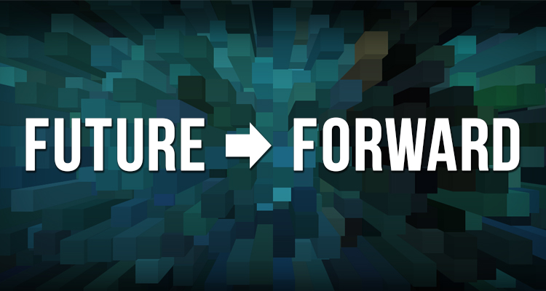
Scenario #2: Circling the Wagons

The world in 2035 is extremely divisive. But many Philadelphians have seen positive changes in returning to what matters most: family, community, and meaningful experiences.
After a divisive and socially conservative President was elected in 2016, there were four years of increasing conservatism, worsening international relations, a volatile stock market with limited economic growth. Support for cities reduced, placing strains on local governments.
Philadelphia’s business community lobbied to institute a Payments in Lieu of Taxes (PILOT) policy, forcing large nonprofits to pay the equivalent of property tax on significant land holdings. While PILOTS generated tens of millions of dollars for the city treasury (primarily from universities and hospitals), it also raised the price for higher education and healthcare and placed an additional financial burden on the largest nonprofit museums and theatres that own facilities.
Efforts to turn around the School District of Philadelphia stalled. By 2025, less than half of students in the city attended the District. Public education is now more like a trade school, while charters and private schools teach more sophisticated academic subjects. District schools have almost no arts and culture.
Constant fiscal insecurity hangs like a dark cloud over the region, creating an environment that is defensive and protective, with a lot of competition for jobs. Class divisions have hardened and there is growing conflict between ethnic groups. While there is strong cohesion ​within​ communities, there is little communication between people of different backgrounds. The middle class has largely disappeared.
However, people have responded to reduced opportunity by building up their communities with what little resources they have, collaborating to focus upon what really matters: family, community, and the desire to make life meaningful. They have simplified their lifestyles, buying less, living in smaller places, and sometimes sharing multigenerational households.
By 2022, the Mayor of Philadelphia had cut the ribbon on three new neighborhood centers in South, West, and North Philadelphia, as part of a plan to centralize community and social services in schools and other neighborhood centers. Several nonprofits found that co-locating in these centers opened up new audiences for them, as well as avoiding PILOT costs.
For most residents, going to the theatre or other performing arts is a special treat, and few people attend more than two performances a year. Arts and culture has divided into two distinct parts. High-end performing arts and world class museums; and community-based arts and culture.
The major organizations have greater visibility, but are challenged to meet rising operating costs. They increasingly depend upon major donors. However, from 2015 to 2035, these institutions lost the generation of donors who had been loyal and generous for decades. Today, organizations need to promise donors more and involve them more deeply in programmatic decisions.
Organizations have to survive on less. The ones that thrive are those that have deep community roots and buy-in from residents. Community-based arts and culture programs emphasize amateur participation and affordable social experiences.
Participatory arts are very popular. People like to dance for socializing and exercise, and enjoy learning to draw, paint, make ceramics, or sing or play instruments in small groups. These organizations are supported by a mix of support from fees, grants, and a lot of volunteerism.
While there are some outstanding organizations that have developed new business models and created inspiring work, it is difficult to produce arts and culture that is not predictable, and programming is less adventurous. Few organizations have the funding to take artistic risks or to update their permanent exhibitions. This also makes it harder for organizations to recruit top talent, with constant high pressure combined with low salaries and less artistic experimentation. The arts tend to reflect the community instead of presenting new ideas, because audiences don’t seek out new or unfamiliar artistic experiences.

