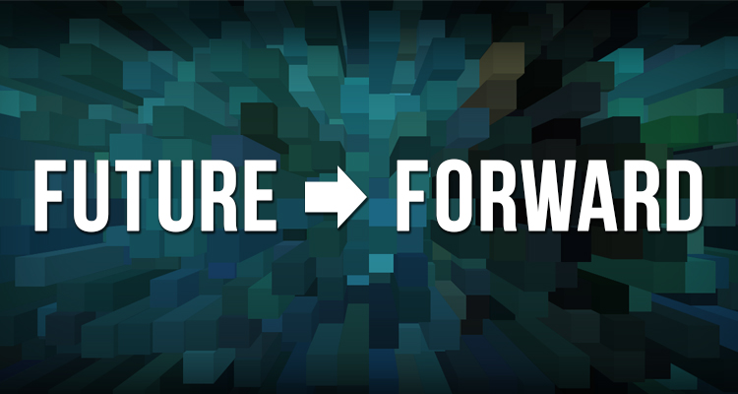
Character Script - Scenario #3: The New Creative Marketplace

I live in a co-living space with other artists and creative types. There is a great sense of community here too, having so many artists living in close proximity to each other. Although more often than not, we’re checking out each others’ work online and collaborating in virtual digital studios than hanging out in-person.
I’m a musician. I don’t sing or play any instruments, but I can replicate any sound I need digitally. I love how expansive I’ve been able to make my sound! The instant I finish a song, I can broadcast it to my fans all over the world in a virtual reality concert. I don’t need an orchestra hall, or a record label, or anything else; it’s so easy to just put myself out there.
For my “day job,” I’m a music and theatre critic. I rarely attend live theater or a concert, though, because my reviews are not just local. I always watch the national US Orchestra’s concerts with my virtual reality viewer. (There’s just one orchestra now, made up of the top musicians from around the country. Lots of them started in the Philadelphia Orchestra!) I experience dance, music, and theater through my VR viewer as well, and I have millions of followers for my feed of recommended performances.
I have creative relationships with people around the world. Later today, I’m co-producing a new piece with a friend in Mumbai who my personal AI assistant introduced me to. Neither of us can afford to travel to meet each other in person, but we’ve gotten to know each other really well and have a lot in common. Sometimes we’ll even take a day off work so we can VR museums and whole cities. Why meet for coffee down the street when you can do it in Rome, from your couch?

