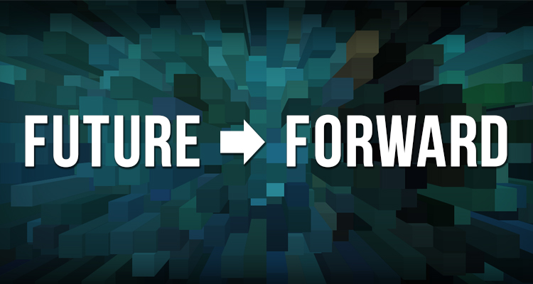
Scenario #3: The New Creative Marketplace

From 2016-2035 technology evolved at a rapid pace, and transformed the way America works and plays. Digital disruptions such as streaming upended music. Amazon disrupted bricks and mortar retail. Uber transformed transportation. These new business models have spread even further throughout the economy, transforming industries like healthcare, social services, and yes, even the arts.
We could have predicted this world in an abstract way in 2016, given how rapidly technology was advancing then, but there are some key events that got us here. In 2020, the Supreme Court ruled that the internet should be designated as a basic human right in the United States, making access more affordable and universal, and effectively closing the digital divide. This paved the way for innovations like universal online voting, robotic personal assistants, and affordable space travel by 2034.
The Collaborative Economy has reached a whole new level in 2035. People rent, borrow, and swap things with great fluidity, and consumers around the world have access to services and resources that were once limited to the few. Gaming programs offer “fantasy orchestras,” in which the viewer can add instruments of their own choosing to interpret the score, or select different conductors.
Few people attend live performances compared to the scale of participation happening online. Holograms have revolutionized the performing arts and blurred the difference between live and virtual performance, with opera, dance, musicals and plays available in real time, in virtual reality in your home. This has expanded the reach of the biggest stars but also allowed amateur and small scale artists to reach niche audiences around the world, allowing experimental and adventurous programming to thrive alongside superstars of pop.
Nonprofit organizations have long since become a platform rather than the primary delivery mechanism for the arts. Many theatres and concert halls have closed for lack of steady revenue to support them, or because they could not be affordably retrofitted for holographic recording systems. Many museums now share collection storage space and registrars, and primarily engage audiences in virtual galleries and exhibitions.
The importance of content has considerably raised the stock of curators and content aggregators, because cultural programming has to be interesting, unique, fascinating, and delivered in a very appealing way. Experience has proven that people will pay for content, but their standards are high. IT technicians earn top dollar, not the stagehands at the Met.
Nonprofit arts organizations face artistic and contributed support competition not just from other organizations, but from individual artists using technology to present themselves. The most successful individual artists are highly entrepreneurial, good at building their “brand” online. But, despite their popularity and broad fan base, it is still difficult to make a living because the broad access to music and visual arts keeps prices low. Emerging artists and smaller nonprofits find it difficult to be discovered if they are not “recommended” by the intelligence on ArtsMyWay, an application that has transformed the creative sector.
While it began as an audience data collection and collaborative marketing tool meant for organizations, ArtsMyWay has grown into a way of life for cultural consumers. Users receive virtual arts experiences, and it suggests other relevant experiences a purchaser might enjoy.
Technology has also vastly expanded the arts and culture market for education. Education reform in 2028 eliminated grades in Pennsylvania, in favor of an emphasis upon mastery of content. Students collect digital badges to demonstrate proficiency, displayed on their online profile. Museums, performing arts, and scientific nonprofits provide many learning tools and resources where students can earn their badges outside of school. For organizations that choose to offer badge programs, it can be a significant source of revenue.
The tourism industry is one of the few industries where reallife experiences are still valued. VisitPhilly is a world leader in using technology to build Philadelphia’s brand. When tourists visit the region, a tour itinerary of museums, historic sites, gardens, and restaurants is curated for them, based on their interests, personal/family history, and ArtsMyWay profile. Virtual reality showcases Greater Philadelphia’s attractions and entices worldwide visitors to escape their everyday, virtual world, and to experience the real thing in Philadelphia.
In this world, artists and organizations that have embraced digital technology have thrived, gaining legions of new fans after shedding old business models.

